Exam And Certification Process

The certification exam is optional and is not a part of the course purchase. Certification Exam guidelines and policies are governed by the Advanced Innovation Group Pro Excellence (AIGPE™).

**CERTIFICATION REQUIREMENTS**

To achieve the professional designation of a Certified 5S Specialist from the Advanced Innovation Group Pro Excellence (AIGPE™), you must:

1. Have completed AIGPE’s 5S Specialist Certification Training to 100%
2. Sit for AIGPE’s 5S Specialist Certification Exam and achieve a minimum score of 60%

There is no other prerequisite to achieving your 5S Specialist Certification.

**EXAM LINK**

At the end of this course, you get a link to the **free** and **optional** exam which, if successfully completed, should provide you with a free and optional 5S Specialist Certification from AIGPE™.

**OUR ACCREDITATION PARTNER AND ASSOCIATION**

1. This 5S Specialist Program and the 5S Specialist Certification you receive is accredited by the globally renowned [**CPD Certification Service**](https://cpduk.co.uk/providers/advanced-innovation-group-pro-excellence-aigpe) **(Provider No: 14627, Certificate No: 62126).**
2. AIGPE™ is also the official [**Authorized Training Partner (ATP)**](https://www.credly.com/badges/540297b7-e923-4120-81a2-a9bfca3c8e07/public_url) **of the Project Management Institute (PMI®) (Provider No. 5573)**. The PMI® Authorized Training Partner seal is a registered mark of the Project Management Institute, Inc.
3. AIGPE™ is officially recognized as a **“provider of choice”** by the **Society for Human Resource Management (SHRM) (Provider No: RP9220).** As a provider, AIGPE™ is authorized to offer [SHRM Professional Development Credits (PDCs)](https://www.credly.com/badges/f946c911-65fd-415e-b736-c3ba83c63739/public_url), helping HR professionals stay compliant with SHRM-CP and SHRM-SCP recertification requirements.

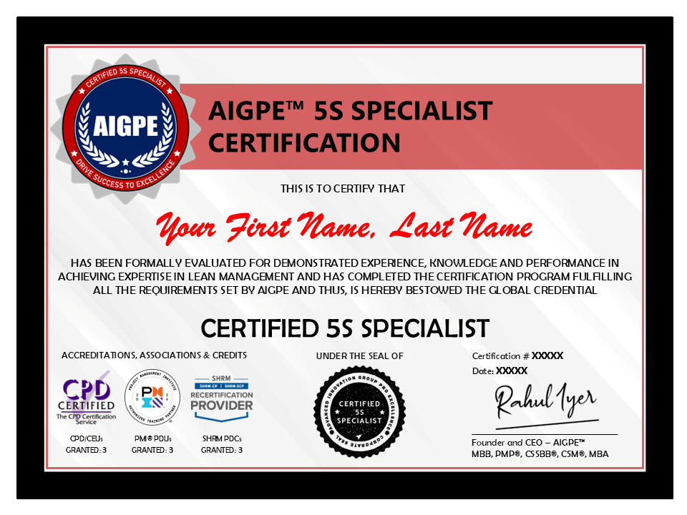**ADDITIONAL IMPORTANT GUIDELINES**

The certification is verifiable. To maintain the quality of the certification, the integrity of the certification exam process, and to adhere to the guidelines set forth by our accreditation partner and associates, the exam is free for the first two attempts. If you fail on the first attempt, you can take the second attempt of the certification exam only after one week.

The AIGPE™ Certified 5S Specialist Exam is an online exam. It consists of 30 multiple-choice questions. Each question carries 1 point. There is no negative marking for any incorrect answers. The minimum percentage required to pass the exam is 60%. That means you need to correctly answer at least 18 out of 30 questions to pass the exam. It is an open book exam. And there is no time limit for the exam. The certification exam link is available in the last lecture of this course. You will be required to upload the Certificate of Completion of this course provided by Packt, hence, please keep it handy before you start the exam.

Students who wish to apply for the certification exam and achieve this credential are required to adhere to all certification exam guidelines and policies set forth by AIGPE™.

**CERTIFICATION**

As a Certified 5S Specialist, you will be issued:

* A Certificate with URL and a QR code that includes the Certification Number
* Your name is added to the Official AIGPE™ Certification Records
* You are granted the right to use the AIGPE™ Certification Credentials. AIGPE™ Certification Credentials can be used as a professional designation in your personal branding material such as resumes, business cards, email signatures, personal website, social media sites or public profiles such as LinkedIn, Job Portals, etc.

We provide electronic copies of certificates only.  
The above certification is enabled for receiving CPDs, CEUs, PDUs, and PDCs.